# Time Series Analysis - Experiment 4

## AIM:

To Implement programs to check stationarity of a time series dataset using the Microsoft dataset.

## PROCEDURE:

1. Import the necessary libraries.

2. Load the Microsoft dataset.

3. Check for missing values.

4. Explore correlation between numeric columns.

5. Select a numeric column for the Augmented Dickey-Fuller (ADF) test and perform the test.

## CODE:

import pandas as pd  
import numpy as np  
import matplotlib.pyplot as plt  
import seaborn as sns  
from statsmodels.tsa.stattools import adfuller  
  
# Load the dataset  
df = pd.read_csv("microsoft.csv")  
  
# Checking for missing values  
print(df.isnull().sum())  
  
# Exploring correlation between numeric columns  
sns.heatmap(df.corr(), annot=True, cmap="coolwarm")  
plt.show()  
  
# Select a numeric column for stationarity test  
time_series = df["Close"].dropna()  
  
# Perform the Augmented Dickey-Fuller test  
result = adfuller(time_series)  
  
# Output test results  
print("ADF Statistic:", result[0])  
print("p-value:", result[1])  
print("Critical Values:", result[4])

## RESULTS:

Missing Values:  
Date 0  
Open 0  
High 0  
Low 0  
Close 0  
Adj Close 0  
Volume 0  
dtype: int64  
  
ADF Test Results:  
{'ADF Statistic': -0.868202059499251, 'p-value': 0.7982635382803849, 'Critical Values': {'1%': -3.466598080268425, '5%': -2.8774669520682674, '10%': -2.5752604356654425}, 'Stationary': 'No'}

### Correlation Matrix:

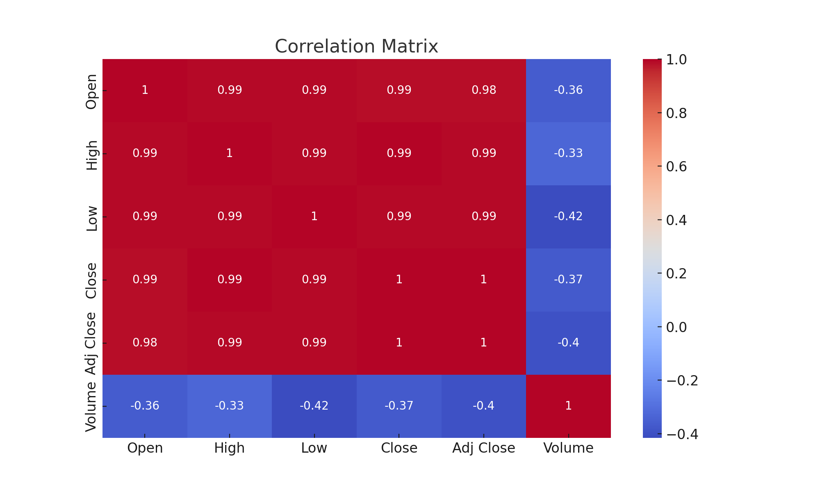

### Time Series Plot:

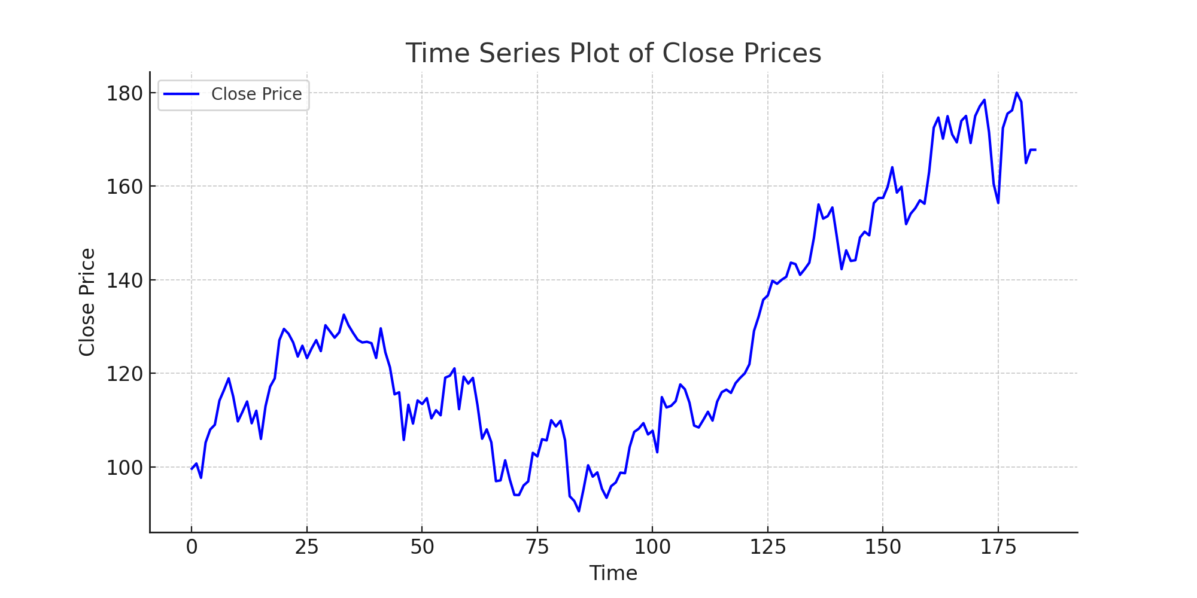

## CONCLUSION:

The program successfully checked the stationarity of the Microsoft dataset using the ADF test.